Even Semester (2023)



**BINUS UNIVERSITY**

**BINUS INTERNATIONAL**

| **Final Project Cover Letter**  **(Individual Work)** |
| --- |

**Student Information:**

**Surname:** Alexander **Given Name:** Brigitte Sharon **Student ID Number:** 2602119190

**Course Code:** COMP6699001 **Course Name:** Object Oriented Programming **Class:** L2AC **Lecturer:** Jude Joseph Lamug Martinez, MCS

**Type of Assignments:** Semester 2 Final Project

**Submission Pattern**

**Due Date:**  12 June 2023 **Submission Date:**  11 June 2023

The assignment should meet the below requirements.

1. Assignment (hard copy) is required to be submitted on clean paper, and (soft copy) as per lecturer’s instructions.

2. Soft copy assignment also requires the signed (hardcopy) submission of this form, which automatically validates the softcopy submission.

3. The above information is complete and legible.

4. Compiled pages are firmly stapled.

5. Assignment has been copied (soft copy and hard copy) for each student ahead of the submission.

**Plagiarism/Cheating**

Binus International seriously regards all forms of plagiarism, cheating, and collusion as academic offenses which may result in severe penalties, including loss/drop of marks, course/class discontinuity, and other possible penalties executed by the university. Please refer to the related course syllabus for further information.

**Declaration of Originality**

By signing this assignment, I understand, accept, and consent to BiNus International terms and policy on plagiarism. Herewith I declare that the work contained in this assignment is my own work and has not been submitted for the use of assessment in another course or class, except where this has been notified and accepted in advance.

Signature of Student:

**Brigitte Sharon Alexander**

# Project Introduction

## Program Description ‘Brew & Bites Billing System’ is a program that allows the administrator to conduct observations on both the buyers and products, but most importantly to manage the billing. The program was made using Java’s utility libraries, Java SQL as its database, and JFrame for the GUI (graphical user interface). Data structures like array lists are implemented in the program for storing usernames and passwords while SQL is utilized for keeping the buyers’ and products’ data. Whenever I go to restaurants, sometimes I get a good glimpse of their monitors and computers. Oftentimes, there are a number of features and buttons that make up their billing system and it gets slightly confusing at times. I’ve then grown curious of how their system works, therefore I decided to place this challenge upon myself to create a billing management system.

## Project Specifications

* + 1. Software Used  
       Netbeans IDE 17
    2. Program Libraries/Packages/Modules & Database
       1. Java Standard Libraries
          1. java.util.ArrayList
          2. java.util.Date
          3. java.text.SimpleDateFormat
          4. java.time.LocalDateTime
          5. java.time.format.DateTimeFormatter
       2. Swing (JFrame)
          1. javax.swing.JOptionPane
          2. javax.swing.table.DefaultTableModel
       3. Rs2xml
          1. net.proteanit.sql.DbUtils
       4. MySQL

## Lessons Learned Throughout the whole project-making process, I learned so much. When it comes to Java, there is just so much you can do with the utilities and libraries given, not to mention the .jar files and other libraries you can get outside of Java in order to create new functions. During this journey, I definitely encountered highs and lows, but I pushed through and persevered. Even so, the entire experience has been enjoyable and eye-opening. Although I wish I had researched a bit more before actually starting the project regarding files and libraries that suit my IDE and project.

# Solution Design (Class Design)

## Program UML Diagram

## Packages & Libraries/Database *SQLManager:* contains the Connector.java class for the SQL database for the buyer and product tables. *arrayList:* contains user.java and userStorage.java, which provide the arrayList to store the usernames and passwords for login. *Bnb.billing.system*: contains all of the main classes for the program, including the GUI forms and functions. *images:* contains images for JFrame and overlay purposes

* 1. **Program Flow**The program begins at the login page (login.java) and allows the user to input  
     a username and password. The ‘show password’ checkbox enables the user  
     to view or conceal their password.   
     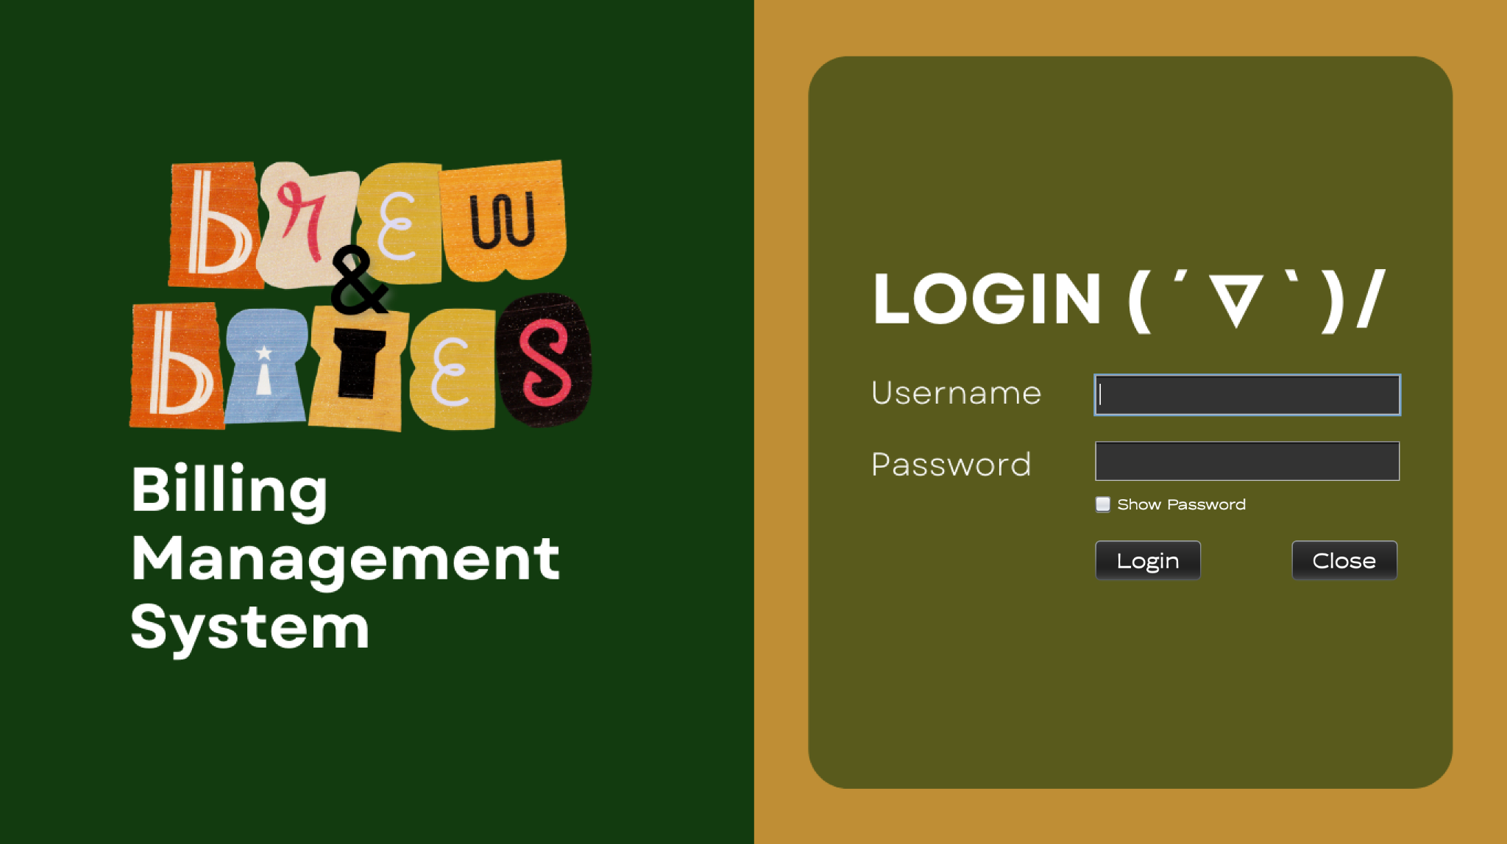  
       
       
       
     If the user decides to exit the program, this pop-up created using the JOptionPane  
     library will appear.  
     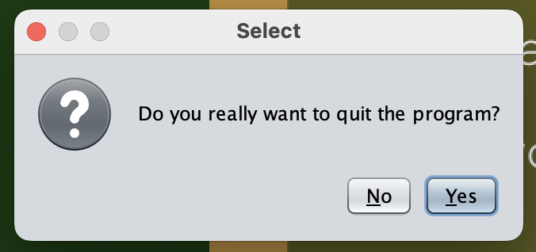  
       
       
       
       
       
       
     In the scenario where the user successfully logs into the system, the homepage  
     will show up. All of the buttons shown below will lead to different classes.  
     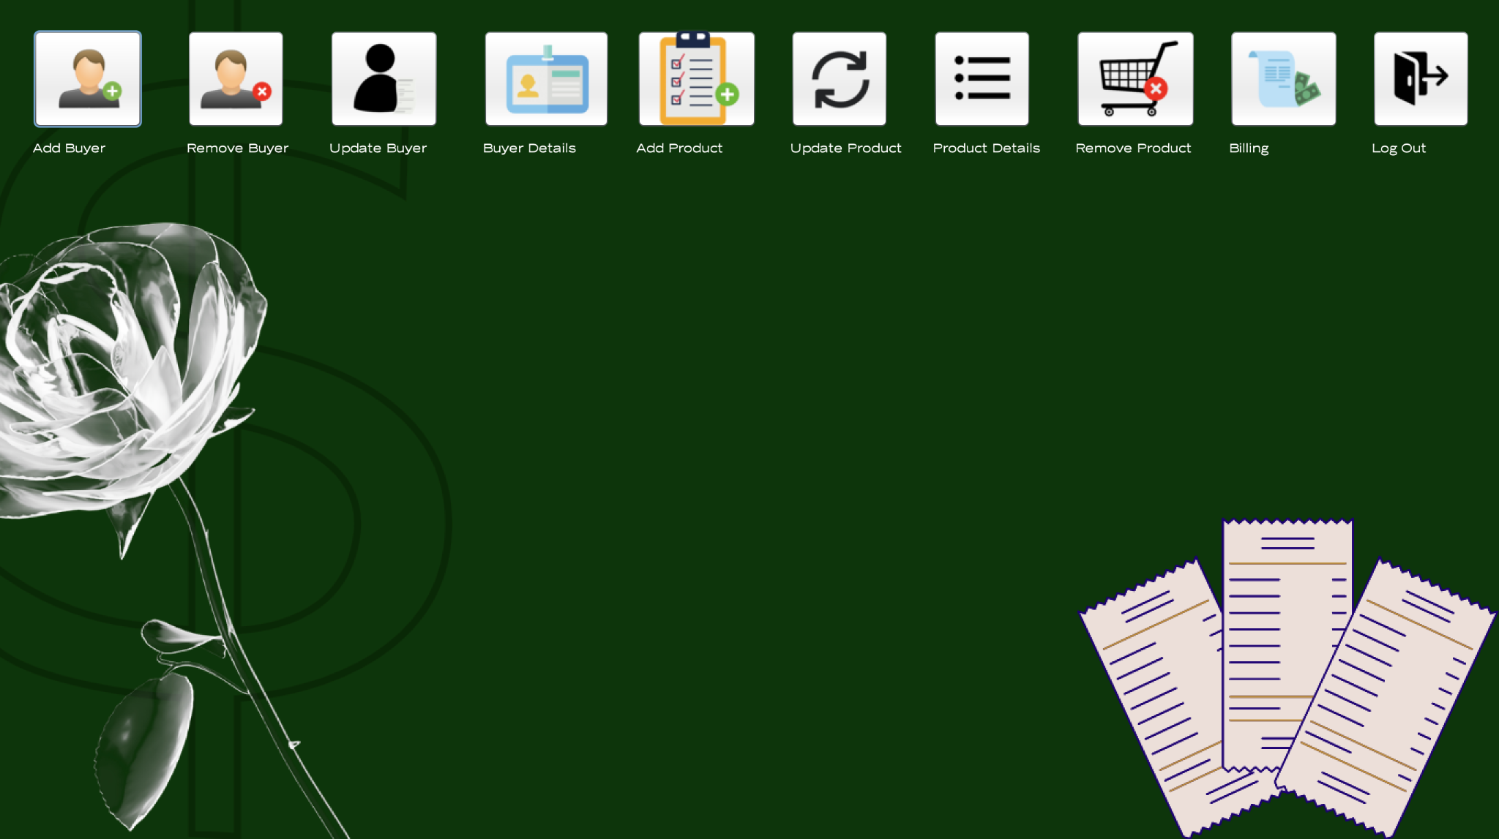  
       
     ‘Add Buyer’ leads the user to this pop-up page.  
       
       
       
       
       
       
       
       
       
       
       
       
       
       
       
       
       
     ‘Delete Buyer’ leads the user to this page.  
     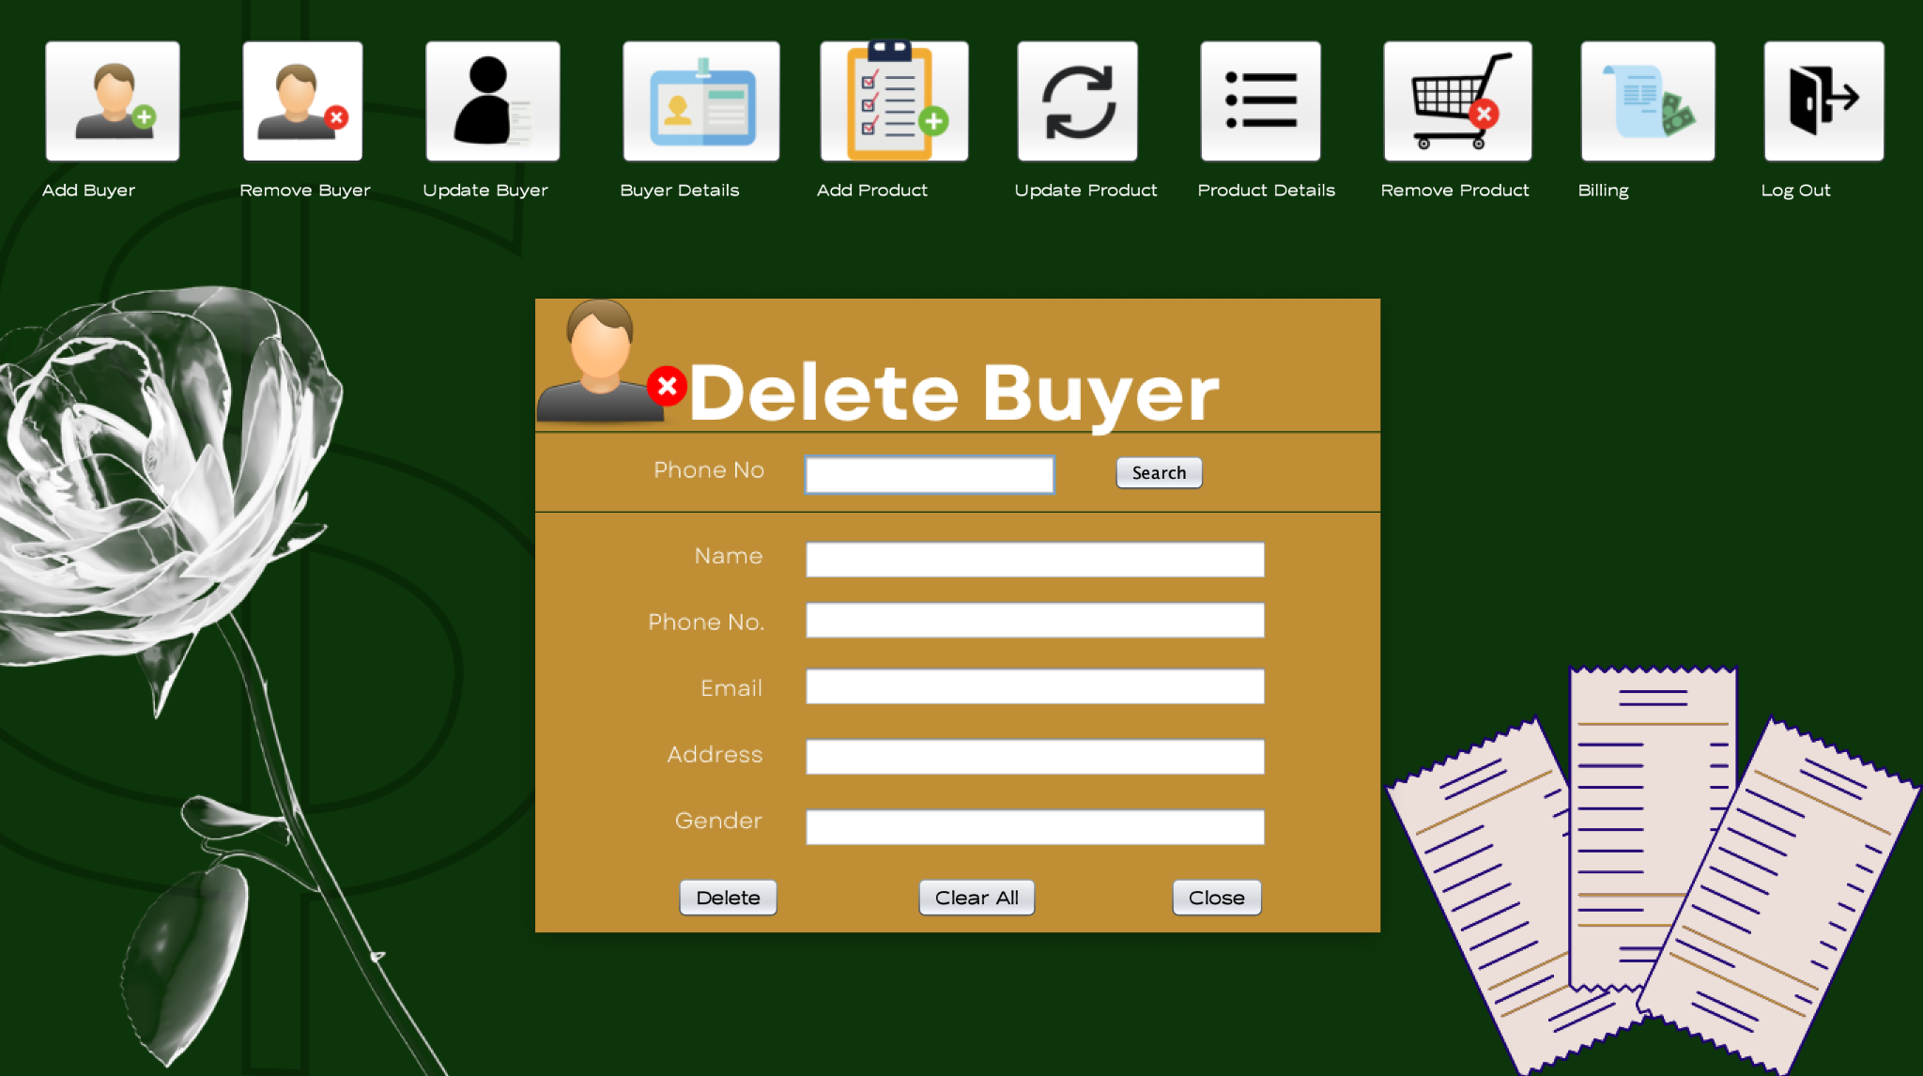  
       
     ‘Update Buyer’ leads the user to this page.  
     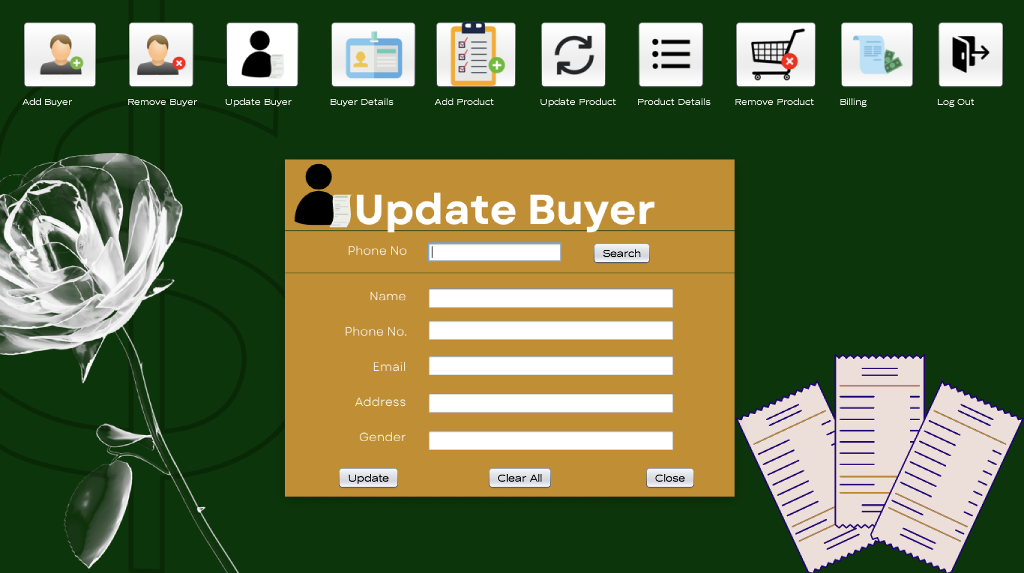  
       
       
       
       
       
       
       
       
     ‘Buyer details’ leads the user to this page.  
     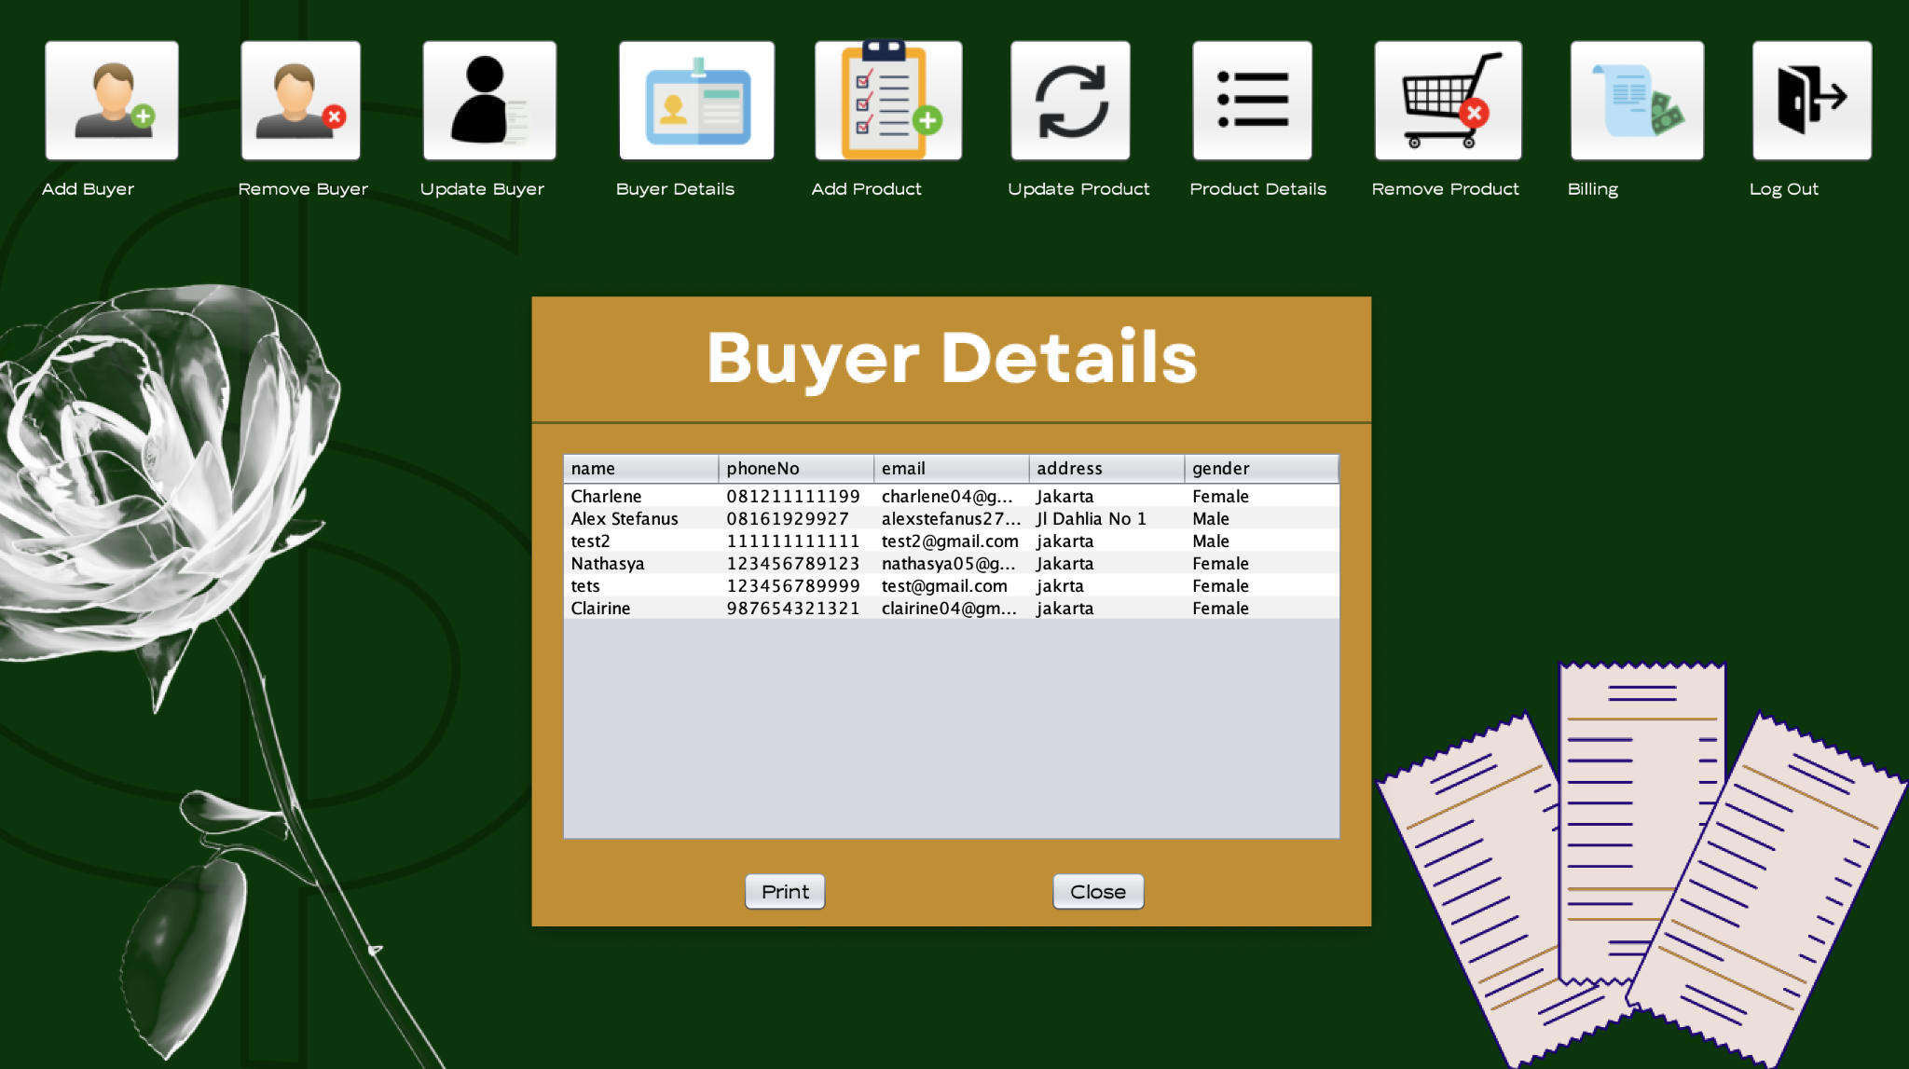  
       
     ‘Add Product’ leads the user to this page.  
     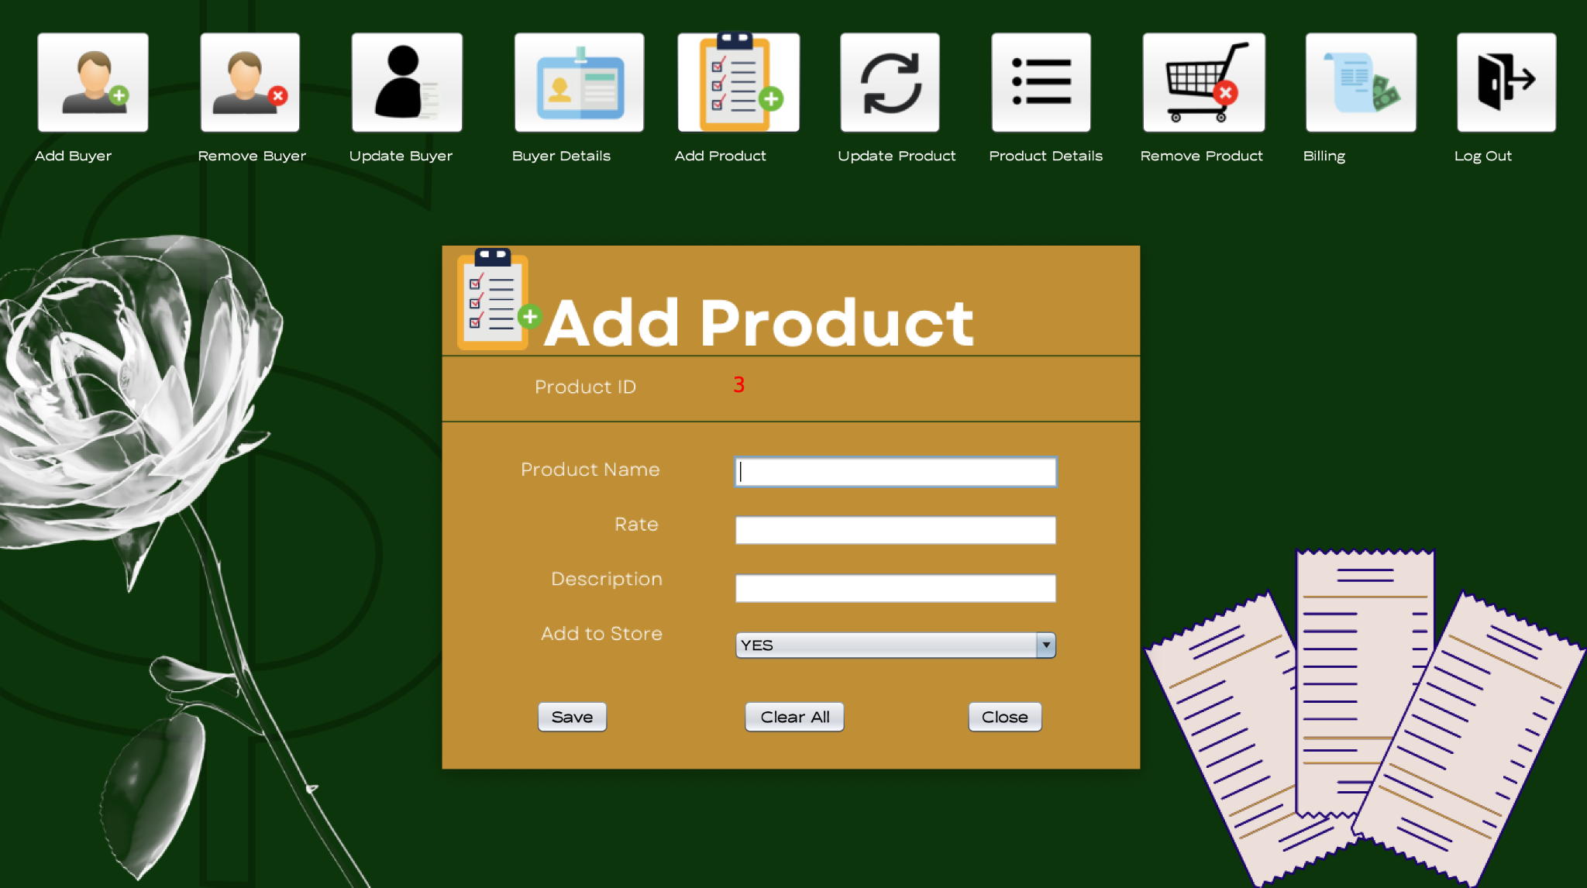  
       
       
       
       
       
       
       
       
     ‘Update Product’ leads the user to this page.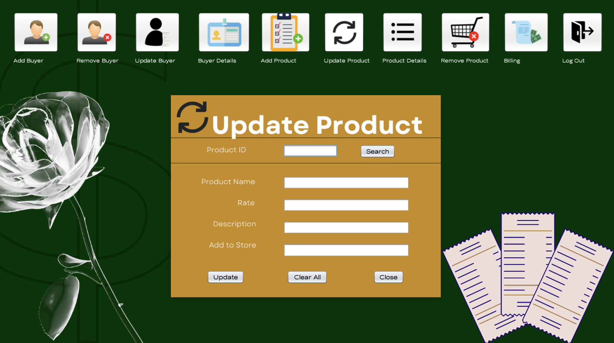  
       
     ‘Product Details’ leads the user to this page.  
     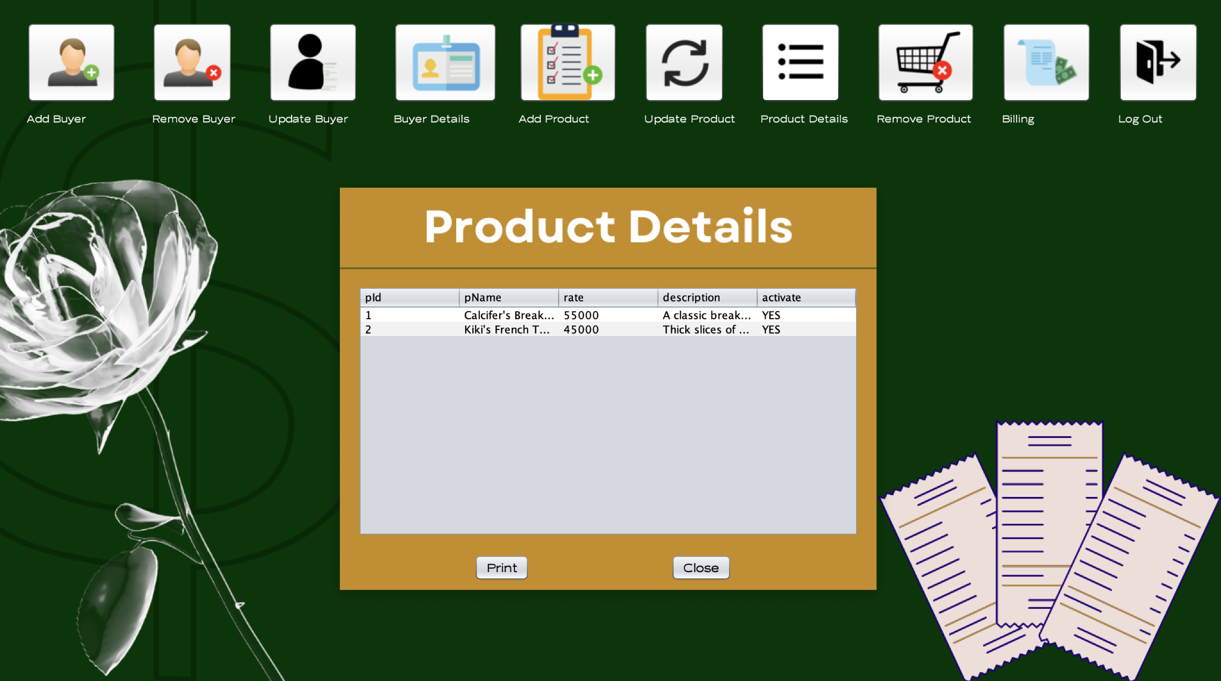  
       
       
       
       
       
       
       
       
       
     ‘Delete Product’ leads the user to this page.  
     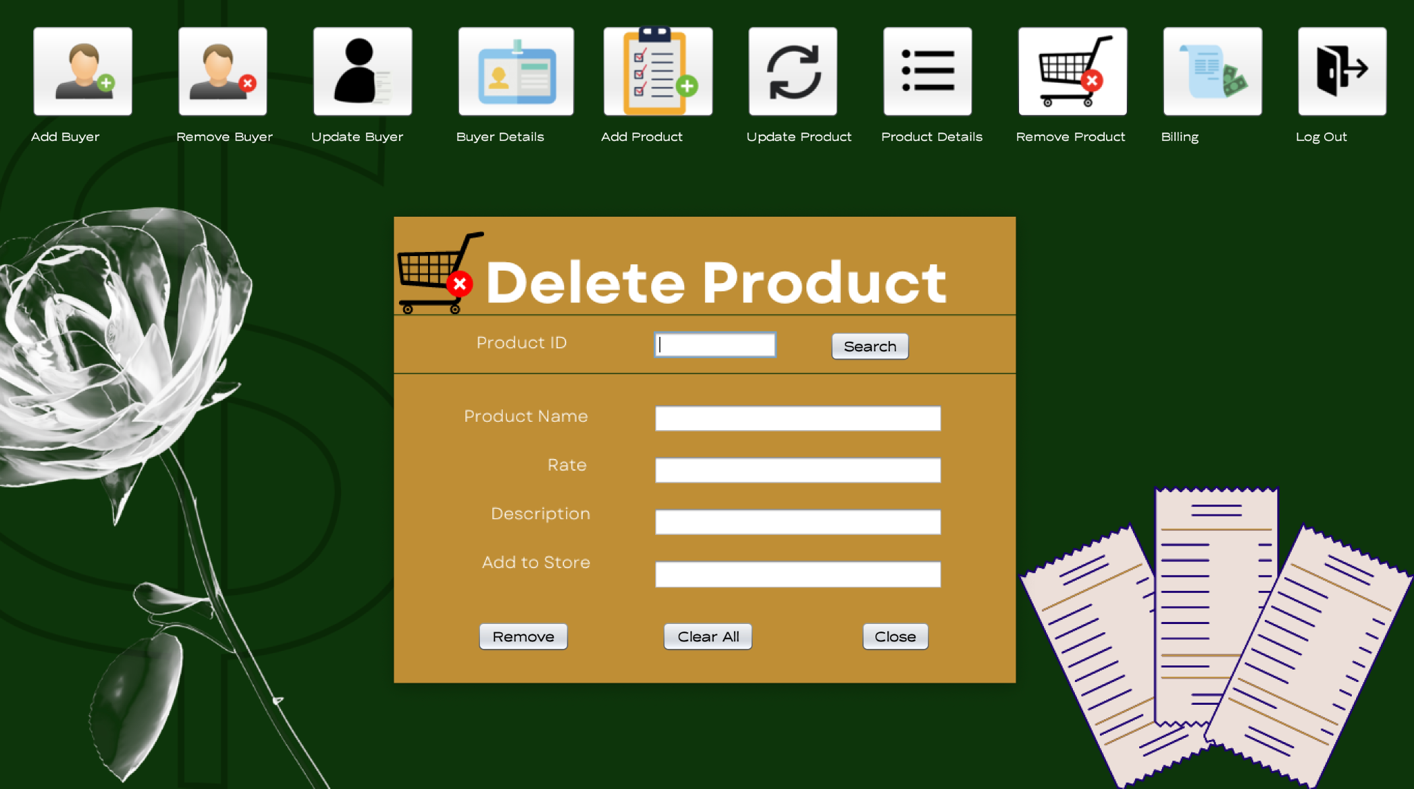  
       
     ‘Billing’ leads the user to this page.  
     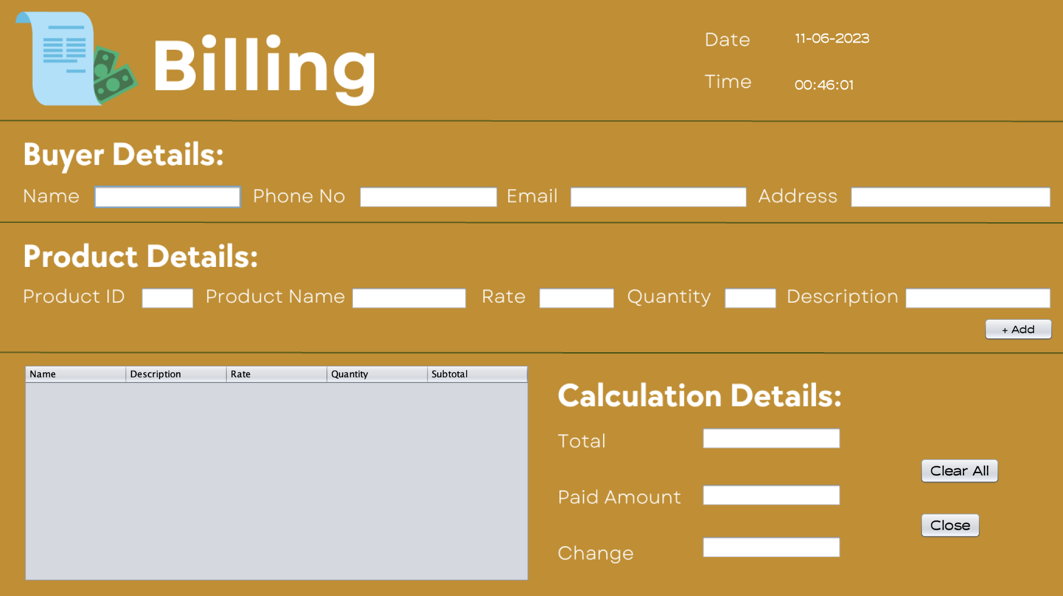  
       
     The logout button simply shows a pop-up confirming if the user wants  
     to exit the homepage or not.  
     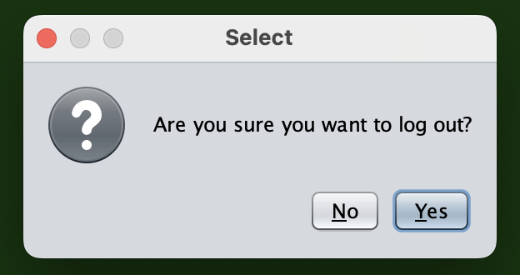  
     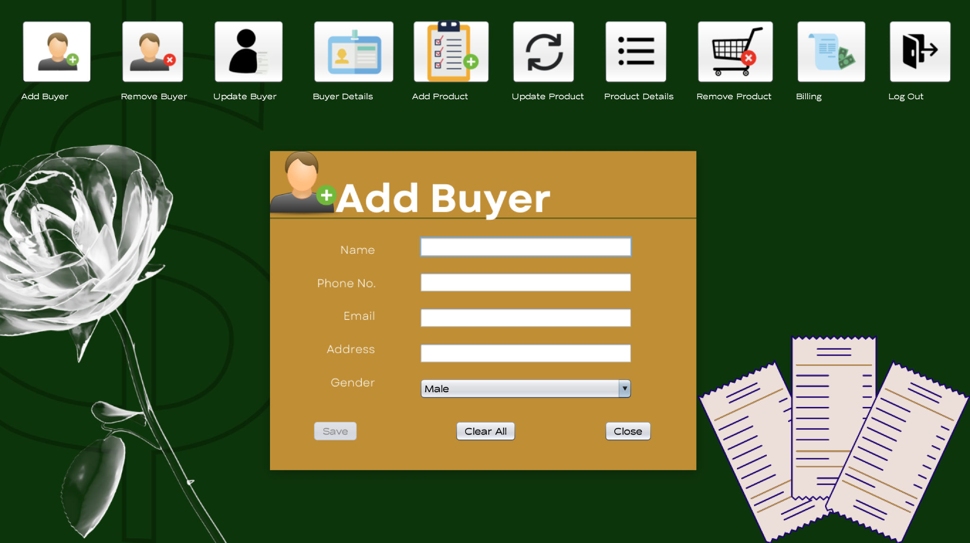

# Code Design and Description

## Connector.java

## This class is used simply for the SQL library; the getCon() method is defined and activates the SQL JDBC local connector by using the password I initially set.

## The green query at line 9 shows the address to the local database and the user ‘root’ and ‘argopuro48’ are my user and password respectively.

## login.java

## Initializing involves importing libraries and methods from other classes and making a public constructor for the class.

## Code for displaying a pop-up confirming when the ‘close’ button is clicked if the user wants to exit the program or not. If the user picks yes (0 is yes), the program terminates.

## When the login button is clicked, an instance of the ‘userStorage’ class is created using the ‘userStorage’ constructor. This class is responsible for storing and managing user information.

## Two user objects are created using the ‘User’ constructor and is then added to the ‘userStorage’ object using the ‘addUser()’ method. These user objects represent admin access credentials and are stored in an ArrayList.

## The program then retrieves the user input and validates them by using the ‘findUserbyUsername()’ and ‘verifyPassword()’ method. If all credentials are valid, the program continues to the homepage. If not, a pop-up will display that something is wrong with either the username or password.

## When the user clicks the check box to show password, the asterisks will change to characters and symbols of the user input. If it’s clicked again, the password will revert back to asterisk form.

## homePage.java

## Each action performed line of code creates a new instance depending on their designated page. For the logout button, a pop-up will ask for the user’s confirmation if they want to log out or not.

## addBuyer.java

## ‘btnSave.setEnabled(false)’ initializes that when the page shows up, the save button will be disabled until the user inputs all the valid information.

## The ‘clear()’ method is used for resetting the whole page.

## The ‘backHomePage()’ method from the interface is used to return to the homepage.

## ‘validateFields()’ is responsible for validating user inputs. For error handling, the pattern ‘^[a-zA-Z0-9]+[@]+[a-zA-Z0-9]+[.]+[a-zA-Z0-9]+$’ is used. It’s designed to match email addresses that consist of alphanumeric characters in regular expression form.

## The method proceeds to check the following conditions for enabling or disabling the ‘save’ button:

## The name text field must not be empty.

## The email text field must match the ‘emailPattern.’

## The phone number text field must not be empty and must have a length of 12 digits.

## The address text field must not be empty.

## The gender text field must not be empty.

## If all the conditions are met, the ‘save’ button will be enabled.

* + 1. ‘backHomePage()’ method implemented in the interface is  
       utilized to get back to the home page.
    2. ‘btnClearAllActionPerformed()’ is responsible for resetting the page
    3. ‘btnSaveActionPerformed()’ handles the save functionality when the  
       corresponding button is clicked. It establishes a connection to the  
       SQL database provided using the ‘Connector.get()’ method.
    4. A prepared statement is created in order to insert the user input into  
       the SQL table called ‘buyer.’ The values are inputted into the   
       placeholders using the ‘ps.setString()’ method.
    5. If the implementation is successful, a pop-up message is displayed  
       saying ‘Successfully updated!’
    6. If it fails, the save button remains disabled.  
       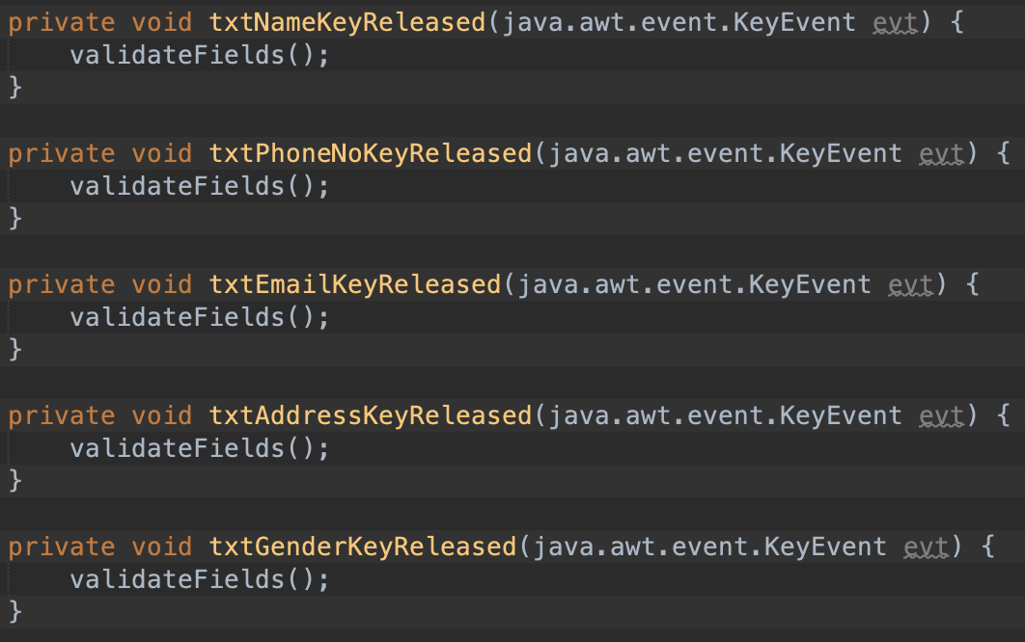
    7. The ‘validateFields()’ method is used to validate the credentials.

## deleteBuyer.java

## The value entered in the ‘txtPhoneNoSearch’ text field is retrieved and assigned to the ‘phoneNo’ variable. Then, a connection to the SQL database is established and a statement executes the SQL queries.

## If the result set contains any matching rows, the code enters the conditional statement. It takes the data from the buyer table and presents it in the given text fields.

## If an exception occurs, an error message is displayed.

## A statement is create and executed to remove the set of data from the database.

## updateBuyer.java

## The value entered in the ‘txtPhoneNoSearch’ text field is retrieved and assigned to the ‘phoneNo’ variable. Then, a connection to the SQL database is established and a statement executes the SQL queries.

## If the result set contains any matching rows, the code enters the conditional statement. It takes the data from the buyer table and presents it in the given text fields.

## If an exception occurs, an error message is displayed.

## The program retrieves the user inputs using the ‘getText()’ method and updates the existing data in the database table using the ‘st.executeUpdate()’ method.

## buyerDetails.java

## When the page is shown, the table automatically displays the data from the ‘buyer’ table from the database using the ‘DbUtils’ library and the ‘setModel()’ method.

## If the print button is pressed, the admin is able to print the table out.

## addProduct.java

## When the page shows up, the product ID will immediately be updated to the latest and unused product ID.

## The ‘st.executeQuery(“select max(pId) from product”)’ method allows this function to work.

## If there is/are existing data in the table, the product ID will be added with 1 and is declared as ‘id.’

## ‘btnSaveActionPerformed()’ handles the save functionality when the corresponding button is clicked. It establishes a connection to the SQL database provided using the ‘Connector.get()’ method.

## A prepared statement is created in order to insert the user input into the SQL table called ‘buyer.’ The values are inputted into the placeholders using the ‘ps.setString()’ method.

## If the implementation is successful, a pop-up message is displayed saying ‘Successfully updated!’

## updateProduct.java

## The value entered in the ‘txtProductIDSearch’ text field is retrieved and assigned to the ‘pId’ variable. Then, a connection to the SQL database is established and a statement executes the SQL queries.

## If the result set contains any matching rows, the code enters the conditional statement. It takes the data from the product table and presents it in the given text fields.

## If an exception occurs, an error message is displayed.

## The program retrieves the user inputs using the ‘getText()’ method and updates the existing data in the database table using the ‘con.preparedStatement.’

## productDetails.java

## When the page is shown, the table automatically displays the data from the ‘buyer’ table from the database using the ‘DbUtils’ library and the ‘setModel()’ method.

## If the print button is pressed, the admin is able to print the table out.

## deleteProduct.java

## A statement is create and executed to remove the set of data from the database.

## The value entered in the ‘txtProductIDSearch’ text field is retrieved and assigned to the ‘pId’ variable. Then, a connection to the SQL database is established and a statement executes the SQL queries.

## If the result set contains any matching rows, the code enters the conditional statement. It takes the data from the product table and presents it in the given text fields.

## If an exception occurs, an error message is displayed.

## billingPage.java

## ‘finalTotal’ is initialized to 0.

## Under the ‘billingPage()’ constructor, Java’s date and time utilities are utilized to update the date and time fields in real time.

## The ‘txtName’ text field retrieves the user input and matches it with any of the data in the database. If there is a match, the rest of its information will be displayed in the given text fields. If not, the fields will remain empty.

## The ‘txtPhoneNo’ text field retrieves the user input and matches it with any of the data in the database. If there is a match, the rest of its information will be displayed in the given text fields. If not, the fields will remain empty.

## The ‘txtProductID’ text field retrieves the user input and matches it with any of the data in the database. If there is a match, the rest of its information will be displayed in the given text fields. If not, the fields will remain empty.

## The code retrieves the text from the ‘txtRate’ and ‘txtQuantity’ text fields and parses them into integer values using ‘Integer.parseInt().’

## The ‘total’ variable is calculated by multiplying the price and quantity together. This comes out as the subtotal.

## A new row is added to the table model using the ‘addRow()’ method.

## The ‘finalTotal’ is then converted to a string and the ‘txtTotal’ text field displays the final total of the order.

* + 1. This code retrieves the text entered in the ‘txtPaid’ text field  
       and assigns it to the ‘paidAmount’ variable.
    2. The ‘paidAmount’ is parsed into an integer value using  
       ‘Integer.parseInt()’ and assigned to the variable ‘z.’
    3. The ‘finalTotal’ is updated by subtracting ‘finalTotal’ from ‘z.’  
       This calculates the change to be returned to the customer.
    4. The updated ‘finalTotal’ value is converted to a string and assigned  
       to the ‘finalTotal1’ variable.

# Miscellaneous

* 1. **References**
     1. https://www.cyberciti.biz/
     2. https://stackoverflow.com/
     3. https://youtube.com/
     4. https://sourceforge.net/
     5. https://geeksforgeeks.com/
     6. https://canva.com/
  2. **Links**
     1. GitHub Repository:   
        <https://github.com/brishar0n/BNBs-Billing-System_OOP-FP>
     2. Demo Video:  
        <https://drive.google.com/file/d/17yuXe23Pa8fNdQdva03fPRxoB99yYr3c/view?usp=sharing>